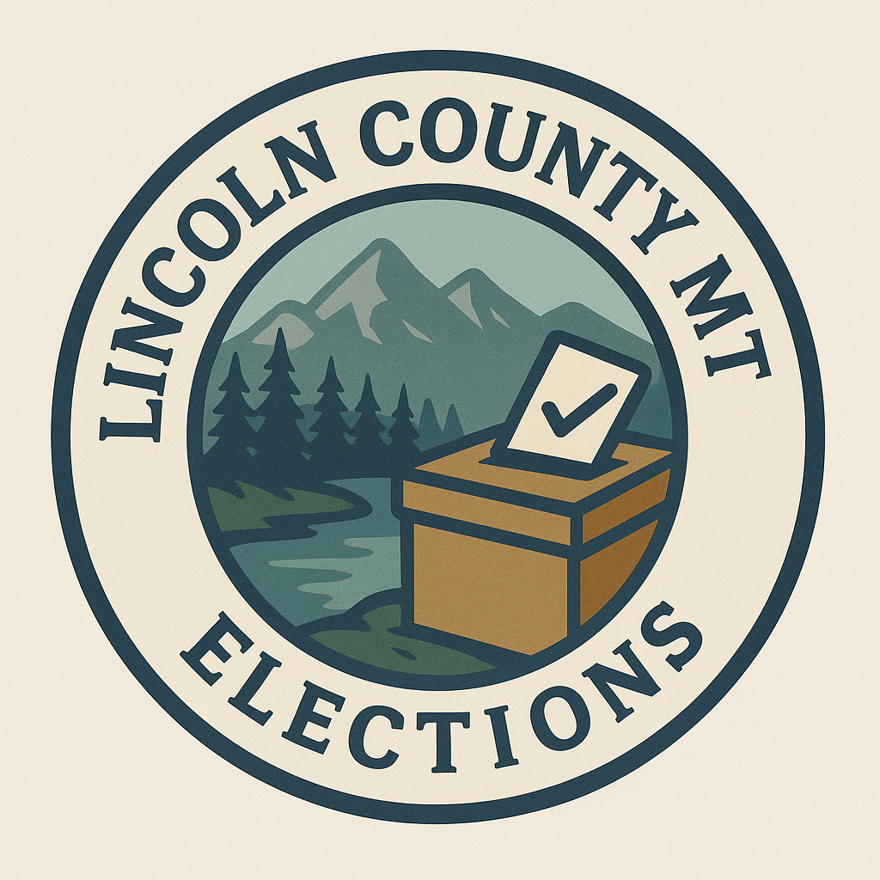
Lincoln County Elections Office
Voter Registration List Request

AN ELECTOR MAY FILL OUT THIS FORM AND MAIL IT TO 418 MINERAL AVE, LIBBY, MT 59923, OR E-MAIL IT TO mhowell@lincolncountymt.gov TO REQUEST A VOTER LIST.

I, (print full name)______________________________________, hereby request the information below:

Full County List (all Active, Inactive, and Provisional)

Precinct(s): _________________________

District: ____________________________

Other – Specify: _________________________________

Record requests are subject to the following charges:
All emailed copies- $15. Fees must be paid in full before files are sent.
Daily Absentee List- $35/per election
Hard Copies- $50 which includes time to gather information pursuant to section 2-6-1006, MCA.

I understand that the item(s) furnished are for noncommercial use, as required by Section 13-2-122, Montana Code Annotated.

My Contact Information:

Phone: _____________________________________ Email: ______________________________

Mailing Address: _______________________________________________________

Date Needed: ________________________________

_______________________________________ ______________________________
Signature of Elector - *by signing here the signer Date
agrees the information furnished shall be
for noncommercial use.

Please return this form with payment (cash, check or money order made out to Lincoln County Elects) to Lincoln County Election, 418 Mineral Ave, Libby, MT 59923.

*The voter registration system is a live system and data changes constantly as county election officials maintain the data. Each extract is static information that is current as of the time the extract is pulled. Additionally, routine list maintenance is done by the county at various times. A requestor of data extracts is responsible for their own analysis of the information provided and is responsible for choosing the time period of purchase.

